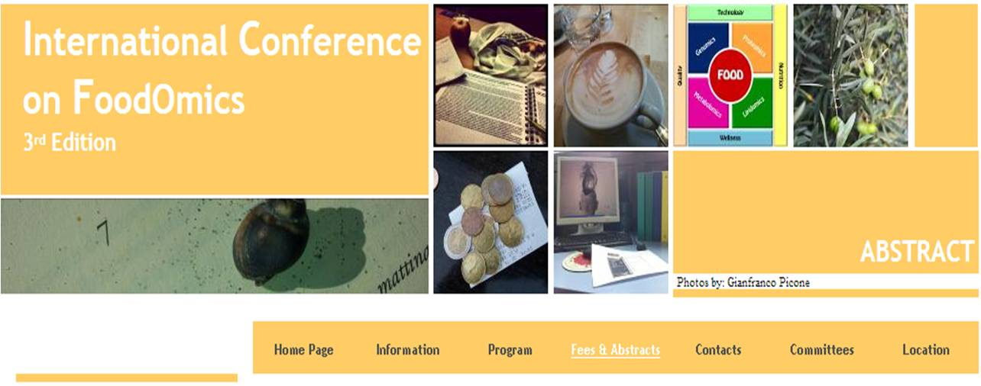

3rd International Conference on FOODOMICS

ABSTRACT SUBMISSION

Deadline for abstract submission: May 5th, 2013

Abstracts have to be sent by e-mail as attached files (Microsoft Word for IBM-compatible) to the secretariat of FOODOMICS
foodomics@unibo.it

Abstracts may include: Tables, Schemes, Figures and References.

To maintain a consistent appearance, all abstracts must be prepared in the following style (see also the template in the next page):
- maximum space limit is half page
- maximum usable area is 16.0 cm wide and 12.0 cm high
- times new roman font (symbol font for special characters)
- 14 point boldface font for the title
- 12 point underlined font for presenting Author (12 point normal font for other Authors, if any)
- 12 point italic font for affiliations
- affiliations distinguished by superscript numbers if necessary
- one blank line left between address and the beginning of the abstract
- one blank line left between the end of the abstract and references/acknowledgment (if present).

>> 3rd edition news <<

SELECTION FOR ORAL PRESENTATION

Eight abstracts will be selected for oral presentations, two for each of the four sessions of the conference (speakers will be notified within the 8th of May). Please select the option “Oral presentation selection” at the end of the abstract template to indicate that you would like your abstract to be considered for an oral presentation and tick two sessions (first and second choice) you would prefer your poster to appear.

BEST POSTERS AWARDS

Two 500 € awards will be assigned to the best submitted abstracts. The awards are reserved to young scientists (< 35 years at the end of the Conference -May 25th, 2013) submitting the abstract as first Author and will be assigned by the Scientific Committee at the end of the meeting. Please select the option “Best Poster Awards” if you are < 35 and you want to attend the award.
ABSTRACT TEMPLATE

Title bolded, 14 point type
Presenting Author: 12 point type, underlined, other Authors (if any)
Author’s affiliation: 12 point type, italicized (affiliations distinguished by superscript numbers if necessary)

The body of your abstract begins here. It should be single-spaced in 12 point type. Use font type Times New Roman, with single spaced lines. Be sure to not exceeding one half A4 page (16 x 12 cm).

[1]. References according to the Vancouver Style

-------------------------------------------------------------------------------------------------------------------------------

Oral presentation selection

Best Poster Awards

1st session: FoodOmics for discovering foods, food components and nutraceuticals

2nd session: FoodOmics for discovering digestion, bioaccessibility and the role of microbiota

3rd session: FoodOmics for discovering the mechanisms of action

4th session: FoodOmics for discovering in clinical sciences

