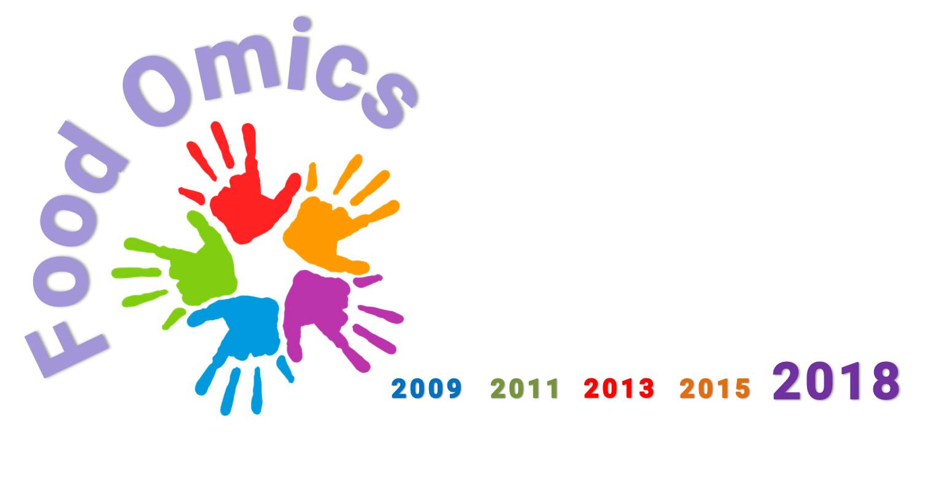
DEADLINES
November 10th, 2017
Deadline for abstract submission for oral presentation selection
December 8th, 2018
Deadline for abstract submission for poster presentation

5th International Conference on Foodomics
Foodomics 2018: from Data to Knowledge

Abstracts must be sent by e-mail as attached files (Microsoft Word for IBM-compatible) to the secretariat of ICF2018: foodomics2018@foodomics.org

Abstracts may include: Tables, Schemes, Figures and References (within the maximum space limit).

To maintain a consistent appearance, all abstracts must be prepared in the following style (see also the template in the next page):
- maximum space limit is half page
- maximum usable area is 16.0 cm wide and 12.0 cm high
- Calibri font (symbol font for special characters)
- 14 point boldface font for the title
- 12 point font for Authors underlining the presenting Author
- 12 point italic font for affiliations
- affiliations distinguished by superscript numbers if necessary
- one blank line left between address and the beginning of the abstract
- one blank line left between the end of the abstract and references/acknowledgment (if present).

_____________________________________________

ABSTRACT TEMPLATE

Title bolded, 14 point type
Authors, 12 point type (Presenting Author: 12 point type, underlined)
Author’s affiliation: 12 point type, italicized (affiliations distinguished by superscript numbers if necessary)

The body of your abstract begins here. It should be single-spaced in 12 point type. Use font type Calibri, with single spaced lines. Be sure to not exceeding one half A4 page (16 x 12 cm).

[1]. References according to the Vancouver Style

Presentation preference: [ ] oral or [ ] poster*

*Please select the option “Oral presentation” to indicate that you would like your abstract to be considered for an oral presentation

